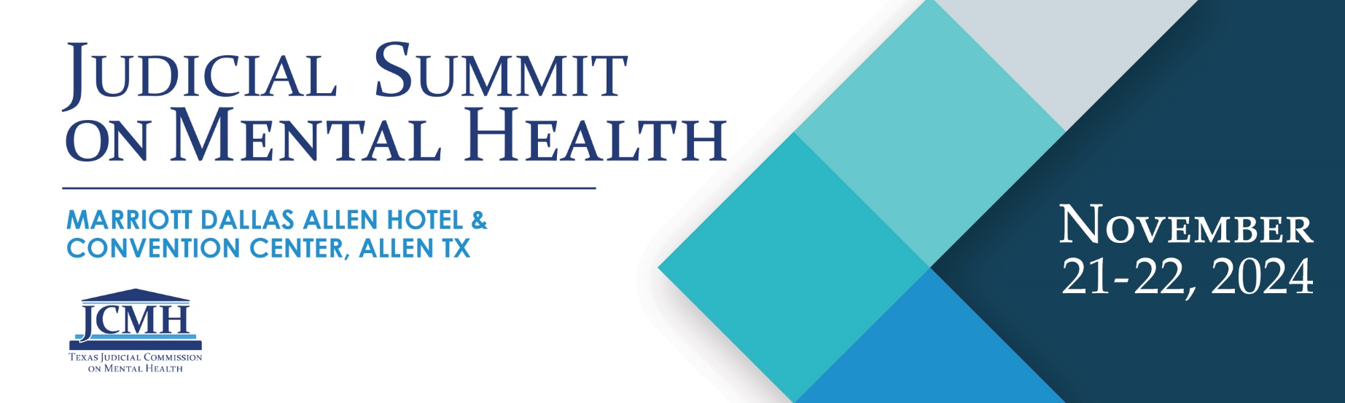

Request for Proposals
The Texas Judicial Commission on Mental Health (JCMH) will host its 7th Annual Judicial Summit on Mental Health, November 21-22, 2024, at the Marriott Dallas Allen Hotel & Convention Center in Allen, Texas. The Summit will be presented live and virtually, but speakers will need to attend in person. More than 400 in-person and 1000 online attendees are anticipated.
This year’s Summit is only 1.5 days long. Within this time, we will have two tracks of presentations (Adult and Youth) and will also have an assortment of 40-minute breakout sessions for participants to attend. JCMH is now accepting applications for breakout session presentations for the 7th Annual Judicial Summit on Mental Health.
If you would like to be considered for a breakout session, please fill out the application below. These presentations will be given twice within the same afternoon, so that more than one group of participants can engage with you and your materials. Breakout session presenters may need to change rooms, are not required to have a powerpoint presentation, and are highly encouraged to conduct an engaging dialog with attendees. A few of the breakout sessions will also be live-streamed to the online audience.
This year we hope to highlight lived-experience experts, cross-disciplinary collaborations, and successful, replicable programs related to best practices in AOT, emergency detention, civil commitment, law enforcement diversion, early identification, mental health courts, competency restoration, and re-entry. The selected presentations should also include one or more of the following aspects: rural innovations, family- or person-centered practices, trauma-informed care, resilience, and equity. JCMH strongly encourages proposals for sessions that present research findings, feature data analysis, and discuss evidence-based practices. Preference will be given to presentations that provide an engaging and interactive experience for the audience.

JCMH Summit Selection Criteria
The selection process is competitive. Proposals will be selected based on their relevance to the field; ability to address multidisciplinary policy/program areas; engaging format; interactive design; style, clarity, and originality; relevance to JCMH stakeholders; cohesion with the full Summit agenda; and the subject matter expertise and training experience of the presenters.
- If proposing a panel format, a maximum of three (3) panelists and one (1) moderator is allowed.
- 2024 Summit breakout session speakers agree to provide JCMH with preliminary electronic copies of any slide decks and/or handout materials for their session(s) no later than Friday, October 18, 2024. These materials will be submitted to state accreditation boards for continuing education credit approval. Presentations will also be reviewed by the JCMH Summit staff.
- Breakout session speakers also agree to provide JCMH with final electronic copies of any slide decks and/or handout materials for their session(s) no later than Wednesday, October 30, 2024. All materials, in PDF format, will be made available to attendees on the Summit Website.
- Breakout session speakers are expected to register for the conference, as well as organize and reserve their own travel and lodging. Reimbursement for travel and hotel will be available to presenters through the JCMH.
- Applicants will receive a confirmation email verifying the receipt of submission. Incomplete applications will not be accepted and will be returned to the sender for completion.
- If your breakout presentation is selected, we will notify you of your selection, and send out the proposed agenda as soon as it is available.
- Presenters are encouraged to distribute business cards, contact information, content materials, and website references to conference attendees.
- Breakout presenters are encouraged to participate at the Q&A Table after their presentation to answer any remaining audience questions.
- Please send your completed application to: jcmhsummit@txcourts.gov by Friday, May 31, 2024.

Speaker Consent
By submitting the 2024 JCMH Summit Breakout Session Presentation Proposal form, and if I am selected as a breakout session speaker, I hereby:
- Agree to submit my preliminary slides and/or handouts to JCMH by October 18, 2024.
- Agree to submit my final slides and/or handouts to JCMH by October 30, 2024.
- Authorize Innovation Event Management as agent for the 2024 Judicial Summit on Mental Health to use or re-broadcast the conference materials used during my presentation including PowerPoint, audio, and video.
2024 JCMH Summit Breakout Session Presentation Proposal
Please send your completed application to jcmhsummit@txcourts.gov by Friday, May 31, 2024.
Your Information:
Name
Phone Number
Email
Employment Organization
Job Title
County
(or Counties)

Will you have any co-presenters or a moderator? (Optional)
 | Co-Presenter 1 | Co-Presenter 2 | Moderator
Name
Employment Organization
Job Title

Breakout Presentation Information:
Presentation timeslots are 40 minutes in length.
Topic
Description
Anticipated audience engagement method
Other information for consideration

